**2.Circle - Class**

Convert the UML diagram to Typescript class. - use number for double

[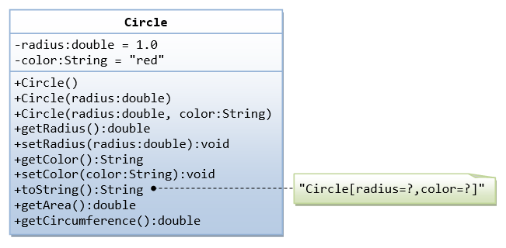](https://github.com/rvsp/typescript-oops/blob/master/images/ClassDiagram_Circle.png)

Ans:

inp.on("close", () => {

class Circle{

constructor(radius,color){

this.radius=radius;

this.color=color;

}

}

getradius()

{

return this.radius;

}

let s1 = new Circle("1.0","red");

console.log(s1.getradius());

});

##### Output:

1.0

(ii)

inp.on("close", () => {

class Circle{

constructor(radius,color){

this.radius=radius;

this.color=color;

}

}

getColor()

{

return this.color;

}

let s1 = new Circle("1.0","red");

console.log(s1.getColor());

});

##### Output:

red

(iii)

inp.on("close", () => {

const pi=3.2412;

class Circle{

constructor(radius,color){

this.radius=radius;

this.color=color;

}

}

getArea()

{

return pi*this.radius*this.radius;

}

let s1 = new Circle("1.0","red");

console.log(s1.getArea());

});

##### Output:

3.1412

(iv)

inp.on("close", () => {

const pi=3.2412;

class Circle{

constructor(radius,color){

this.radius=radius;

this.color=color;

}

}

getCircumference()

{

return 2*pi*this.radius;

}

let s1 = new Circle("1.0","red");

console.log(s1.getCircumference());

});

##### Output:

6.2824

# 1. Class - Movie

The class Movie is stated below. An instance of class Movie represents a film. This class has the following three properties:

* title, which is a String representing the title of the movie
* studio, which is a String representing the studio that made the movie
* rating, which is a String representing the rating of the movie (i.e. PG­13, R, etc)

a) Write a constructor for the class Movie, which takes a String representing the title of the movie, a String representing the studio, and a String representing the rating as its arguments, and sets the respective class properties to these values.

b) The constructor for the class Movie will set the class property rating to "PG" as default when no rating is provided.

c) Write a method getPG, which takes an array of base type Movie as its argument, and returns a new array of only those movies in the input array with a rating of "PG". You may assume the input array is full of Movie instances. The returned array need not be full.

d) Write a piece of code that creates an instance of the class Movie with the title “Casino Royale”, the studio “Eon Productions”, and the rating “PG­13”

Ans:

inp.on("close", () => {

class Movie{

constructor(title,studio,rating){

this.title=title;

this.studio=studio;

this.rating=rating;

}

}

getPG()

{

var inputarr=[];

return this.rating;

}

let s1 = new Movie("Casinp Royale","Eon Production","PG13");

console.log(s1.getPG());

});

##### Output:

PG13

3. Write a “person” class to hold all the details.

Ans:

inp.on("close", () => {

class person{

constructor(name,mailid,phoneno){

this.name=name;

this.mailid=mailid;

this.phoneno=phoneno;

}

}

getdetails()

{

return this.name;

}

let s1 = new person("John","johnabc@gmail.com","9566344778");

console.log(s1.getdetails());

console.log(s1);

});

##### Output:

John

John

johnabc@gmail.com

9566344778

4. write a class to calculate uber price.

Ans:

inp.on("close", () => {

class ubertrip{

constructor(date,Driver,Fare,Car,City,Paymentmethod){

this.date=date;

this.Driver=Driver;

this.Fare=Fare;

this.Car=Car;

this.City=City;

this.Paymentmethod=Paymentmethod;

}

}

getFare()

{

return this.Fare;

}

let s1 = new person("05.12.2021","John","Rs.16","Uber","Chennai","online");

console.log(s1.getFare());

console.log(s1);

});

##### Output:

Rs.16

05.12.2021

John

Rs.16

Uber

Chennai

online